Presentation Primary School
Emergency Closure Weekly Lesson Plan
Class: Junior Infants Teacher: Ms Fitzgibbon, Ms O’ Malley, Ms Roben Room: 19, 20, 21
Week: Term 3 Week 5 Monday – Friday
Please try and complete English, Maths and Writing today
Subject: | Activities:
English: | Phonics  ● Sounds Like Phonics: https://slp.cjfallon.ie  Click on: Activity Book A - Unit 3 – The Toy Shop, Letter u - Follow this website to give you free access to online games: The children are familiar with these games from class.  Reading  ● Continue to log on to the website Raz Kids https://www.kidsa- z.com/main/Login every day and read the books assigned to your child in the ‘My Assignments’ section. Everyone should have received log in details via text. If not, follow the instructions below:  Step 1: Go to https://www.kidsa-z.com/main/Login -  Step 2: Enter teacher's username and press Go. –  Step 3: Select your name on the class chart. -  Step 4: Enter your password and press Go.  Step 5: Click on the section My Assignments to access your child’s assigned reading books  ** If you are having any trouble logging in, please email the class teacher.  - - Ms. O’Malley – msomalley@preslimerick.ie  - - Ms. Fitzgibbon – msfitzgibbon@preslimerick.ie  - - Ms. Roben – msroben@preslimerick.ie  - Well done to everyone who is doing their reading, it’s great to see you all logging on and completing your tasks.
Maths: | Today we are still looking at weight and things that are heavy and light. Have a look at todays video.  https://www.youtube.com/watch?v=RkymyZDufsw&frags=pl%2Cwn  Can you draw 3 things that are light and 3 things that are heavy. Colour the light things green and the heavy things red.  Now have a look at the maths worksheet for today have a chat about the different pictures you can see. Can you tell which items are heavy and which items are light?  **If you have access to a printer complete the worksheet**
Writing | Our letter today is the letter u, we would like you to practise writing the letter u and why not practise our letter from yeaterday also the letter r
 | Extra work we would like you to try (This work is optional)
Gaeilge | 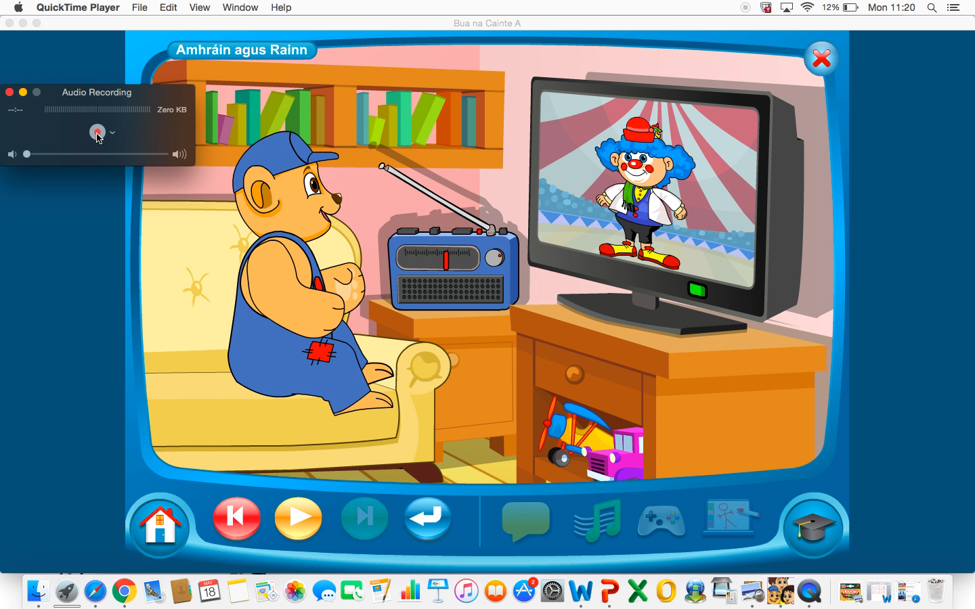  Have a listen to the audio clip above. (Double click on the audio link) It is a little song called Tá Teidí sa seomra suí (Teddy is in the sitting room)  Tá Teidí sa seomra suí, Tá Teidí sa seomra suí ag feachaint ar an teilifís a haon, a dó, a trí x2  (Teddy is in the sitting room, Teddy is in the sitting room, Teddy is in the sitting room, watching the television, 1, 2, 3)  Listen to it a few times and then try and sing along
Physical Education and Well being: | Today we would like you to try some yoga, remember it is very important to stay active during this time.  Find some free space somewhere and follow the instructions!  https://www.youtube.com/watch?v=pT-s1-phgxs
Science | Today we are going to look and see what a plant needs to grow. Now that the weather is getting better lots of people are planting seeds so that they will have lovely flowers during the summer in their garderns.  What do we need to grow big and strong?  Do you think seeds need the some of the same things?  Have a look at this video and see if you were right!  https://www.youtube.com/watch?v=dUBIQ1fTRzI  Have a look at the worksheet and chat about what a plant needs to grow.

