Presentation Primary School
Emergency Closure Weekly Lesson Plan
Class: Junior Infants Teacher: Ms Fitzgibbon, Ms O’ Malley, Ms Roben Room: 19, 20, 21
Week: Term 3 Week 5 Monday – Friday
Please try and complete English, Maths and Geography today
Subject: | Activities:
English: | Phonics  ● Sounds Like Phonics: https://slp.cjfallon.ie  Click on: Activity Book A - Unit 3 – The Toy Shop, Letter n- Follow this website to give you free access to online games: The children are familiar with these games from class.  Reading  ● Continue to log on to the website Raz Kids https://www.kidsa- z.com/main/Login every day and read the books assigned to your child in the ‘My Assignments’ section. Everyone should have received log in details via text. If not, follow the instructions below:  Step 1: Go to https://www.kidsa-z.com/main/Login -  Step 2: Enter teacher's username and press Go. –  Step 3: Select your name on the class chart. -  Step 4: Enter your password and press Go.  Step 5: Click on the section My Assignments to access your child’s assigned reading books  ** If you are having any trouble logging in, please email the class teacher.  - - Ms. O’Malley – msomalley@preslimerick.ie  - - Ms. Fitzgibbon – msfitzgibbon@preslimerick.ie  - - Ms. Roben – msroben@preslimerick.ie  - Well done to everyone who is doing their reading, it’s great to see you all logging on and completing your tasks.
Maths: | Today we are going to be looking at combining numbers. Before we begin can you count from 1-10? After that can you try and count backwards from 10-1?  Try it a few times  - Speak like a robot  - Say it very slowly  - Say it as quickly as you can  - Sing it!  We looked at this last week can you remember? We added lots of different things, on todays worksheet we will be adding sweets maybe you could act out the sums before doing the worksheet with concrete materials, you can use lots of different things like pasta shells, toys, crayons etc  **If you have access to a printer complete the worksheet**
Geography | Now that the weather is getting better and we are coming towards the end of May we are going to learn all about Summer.  Summer is one of the the four Seasons, can you name the other three?  Have a look at the Powerpoint and discuss the signs of Summer, can you see any of the signs near you?  Now have a look at the worksheet, have a chat about what you can see, smell, feel, taste and hear in Summer, then maybe you could draw them and colour them in.  (Both the Powerpoint and the worksheet can be found in the home learning document section along with this plan)
 | Extra work we would like you to try (This work is optional)
Gaeilge | Click on the link below to bring you to todays video, listen to teacher say the words and then copy her.  https://drive.google.com/file/d/1bwVU-5RM-jHWTNyOilG3h2J-zekBulOs/view  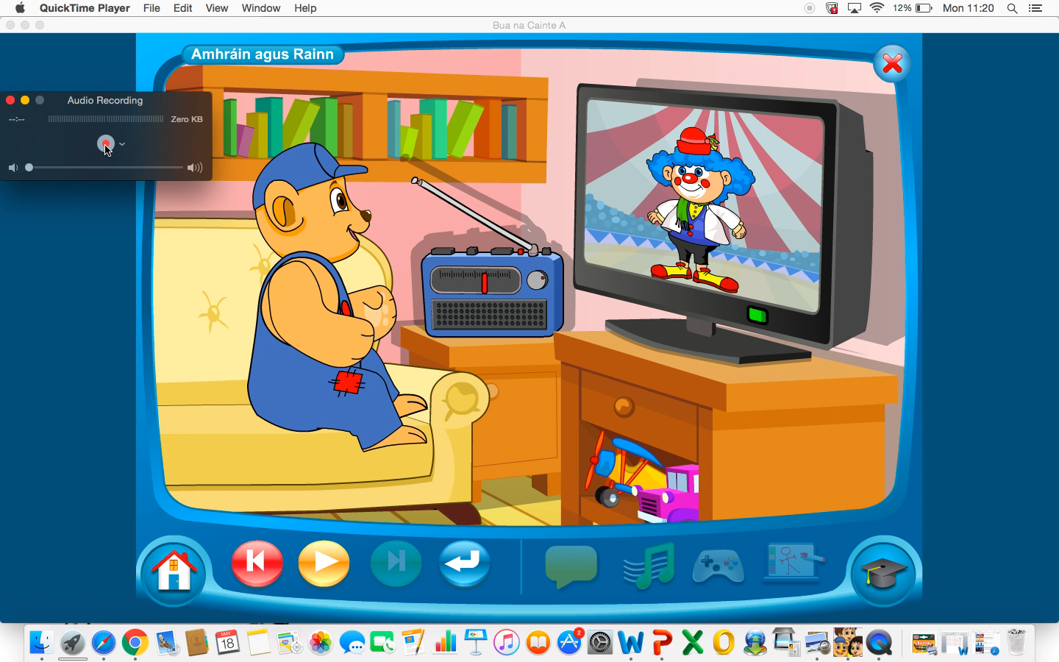  Have a listen to the song from yesterday and try and join in. (Double click on the audio link) It is a little song called Tá Teidí sa seomra suí (Teddy is in the sitting room)  Tá Teidí sa seomra suí, Tá Teidí sa seomra suí ag feachaint ar an teilifís a haon, a dó, a trí x2  (Teddy is in the sitting room, Teddy is in the sitting room, Teddy is in the sitting room, watching the television, 1, 2, 3)
Physical Education and Well being: | Today we would like you to try a guided meditation.  Find some free space somewhere and follow the instructions!  https://www.youtube.com/watch?v=ZBnPlqQFPKs&frags=pl%2Cwn
Music | Today we would like you to try this ‘Guess the sound Quiz’ Have a listen to the different sounds and see if you can tell what they are!  The answer will be given after your guess.  https://www.youtube.com/watch?v=n1m4h79JZso&t=1s  After that have a listen to this song, you may remember it from singing it at school, join in if you can and try the actions.  https://www.youtube.com/watch?v=wR9HI9IkmH8&frags=pl%2Cwn

