Monday, 30th of March 5th class

Today’s activities:
Maths | - Master your maths Day 1  - Maths Eyes
English | - Cloze Text  - Reading 15 minutes daily
Gaeilge | - Practice new words.  - Revise verbs.  - Group 3: phrases
S.E.S. E | - New Project- Levers
P.E/wellbeing | - P.E activity

- All the worksheets will be available on one document every day. I will also add other resources to our 5th class home learning page.

- Don’t forget to sign up to the different publishers: Edco, Folens and CJ Fallon as all the books are available online for free!

- Can complete the work in your copy on a sheet of paper!

Book: Master Your Maths available on: CJ FALLON Mon p8
Skip Q6

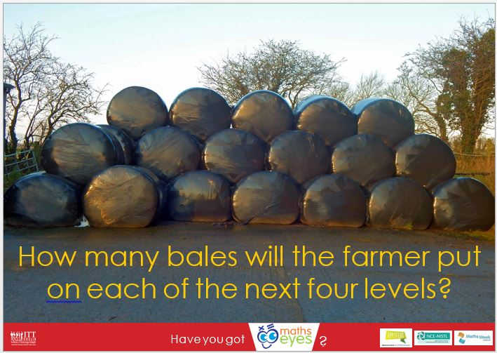
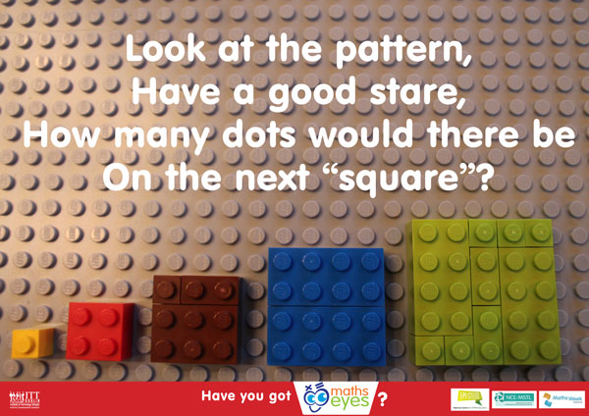
Have you got Maths Eyes
English Cloze Text: Let’s Talk Literacy p17 Available on: Edco
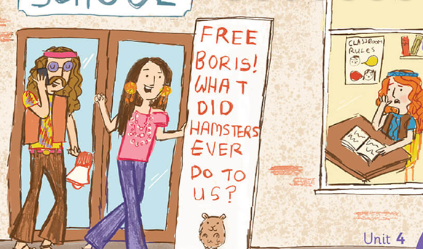
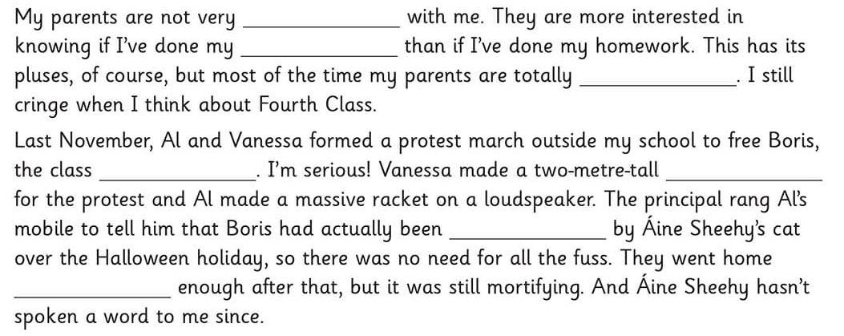
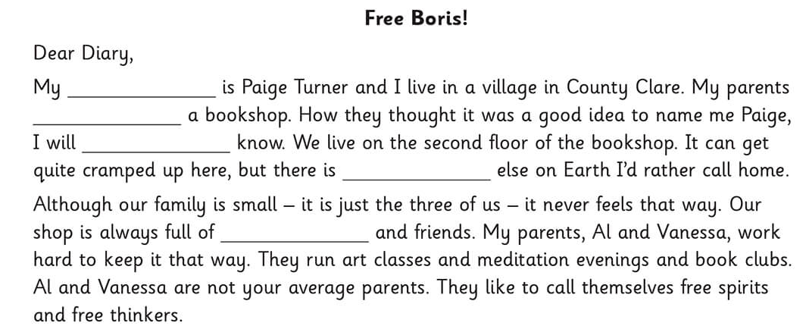
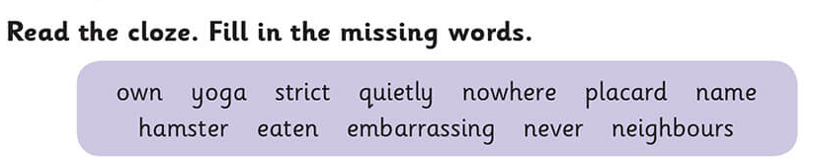

Gaeilge An Aimsir: The weather – This work is for the full week.

Try to learn one word and one verb a day depending on your group. If you can’t remember your group learn the Gaeilge that suits you best.
If you need help with pronunciation go to https://www.teanglann.ie/en/fuaim/.
- Write in the Irish word.
- Select Munster dialect.
Grúpa 1,2 agus 3
fliuch | wet
tirim | dry
Scamallach | cloudy
drochlá | bad day

Grúpa 2: Fréamh – you will be revising roots of verbs
- duisigh | To wake
- maisigh | To decorate
- deisigh | To fix
- bailigh | To collect

Grúpa 3: Aimsir Chaite (past tense)
Chuidigh mé | I helped
D’fhoghlaim mé | I learned
D’imir mé | I played
Cheistigh mé | I questioned
Chuimhnigh mé | I remembered

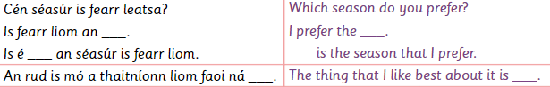
Grúpa 3: Abair Liom G p 162
S.E.S. E | Science: Week 3  Research topic: Levers.  Aim: What is a lever?  What is its function- what does it do?  Can you give an example of a lever?  By the end of the week can you orally answer these 3 questions  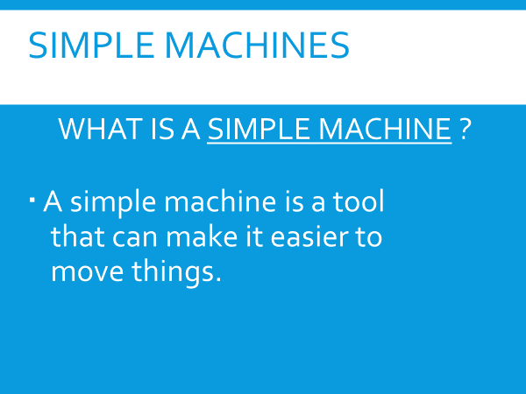  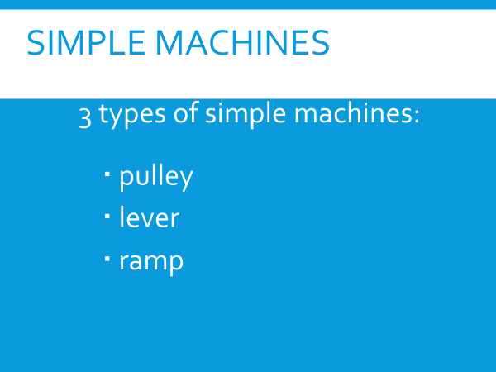  You are going to only research one type of simple machine which is a lever.
P.E | Try out P.E with Joe on youtube, everyday he uploads a new P.E lesson. Its important to still stay active  This is the link to his most recent lesson:  https://www.youtube.com/watch?v=qGKGNzNbWjU
Reading: | These are some of the links from Google Classroom that I uploaded.  David Walliams audio books available daily from 11:00 a.m. taken from his book “The World’s Worst Children”.  https://www.worldofdavidwalliams.com/  Friday’s book:  https://soundcloud.com/harpercollinspublishers/the-worlds-worst-children-3-2/s-17dYCFrEHVO
Maths online games | N -RICH maths games  https://nrich.maths.org/14536  TOPMARKS : https://www.topmarks.co.uk/maths-games/7-11-years/ordering-and-sequencing-numbers  IXL: https://ie.ixl.com/math/class-5
Coding resource: | Microbits: https://makecode.microbit.org/  Hour of Code – available in 45 languages https://hourofcode.com/ie  Scratch https://scratch.mit.edu/
Mindfulness | https://www.youtube.com/watch?v=ZBnPlqQFPKs  https://www.youtube.com/watch?v=Bk_qU7l-fcU

